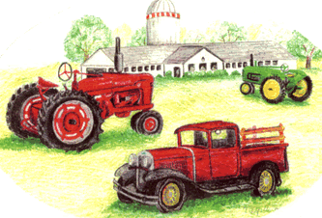Name:_______________________________________________
Sandhills Antique Farm Equip Event
Pre-Registration Form
Contact Person
Sheila Lewis
910-893-5249
All Food Vendors please pre-register with Neal Cutler-910-897-2838

Address:______________________________________________

City:_________________________________________________

Cell Phone:___________________________________________

Home Phone:__________________________________________

E-mail Address:________________________________________

Did you receive a post card in mail? Y/N ________

Can we add you to email list? Y/N_____________

Are you camping on site? Y/N______ Number of people_____

What size area do you need for your display?_______________
Category of your items for sale /demonstration/exhibition
Mark all that apply
Antiques _____ Arts and Crafts_____

Ag & Livestock_____ Health & Beauty_____

Household/Clothing_____ Farm Equipment _____

Military Equipment _____ Non-Profit Organization _____

Political/State/County_____ Vehicles_____

Others____________________________

